Conducting Strategy Optimization with Multiple Periods
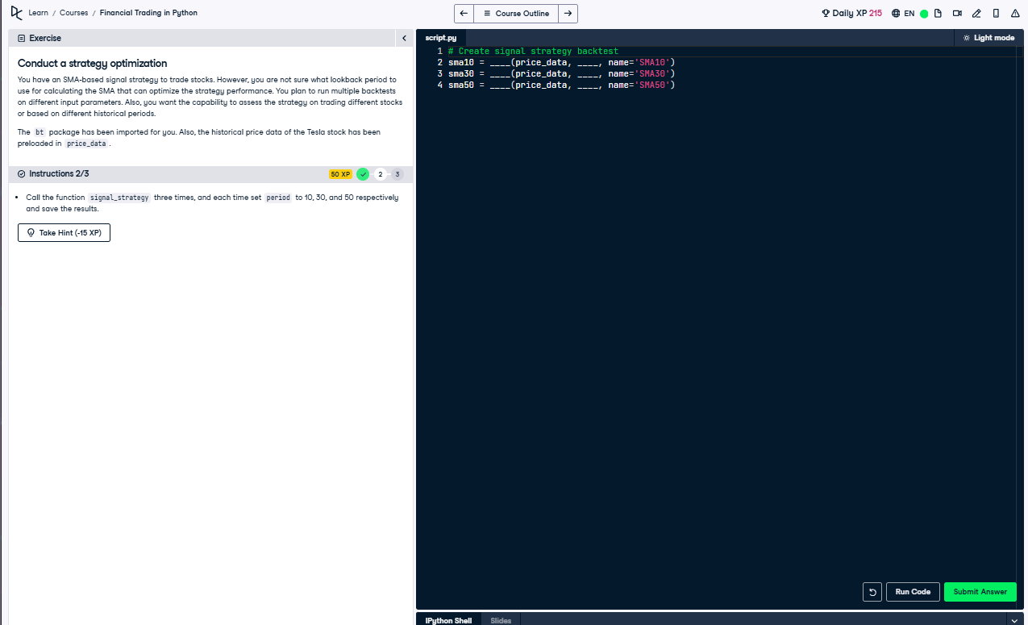

Python Code
# Create signal strategy backtest
sma10 = signal_strategy(price_data, 10, name='SMA10')
sma30 = signal_strategy(price_data, 30, name='SMA30')
sma50 = signal_strategy(price_data, 50, name='SMA50')

Explanation
This code runs the signal strategy three times using different SMA periods (10, 30, 50). Each run creates a backtest to check how the strategy performs with different lookback windows. The results are stored in variables for comparison of each version’s trading effectiveness.

